|  |  |  |  |  |
| --- | --- | --- | --- | --- |
| C:\Users\David\Dropbox\rossmoyne.png  **Reading Time**: An initial **2 minutes** to view **BOTH** sections | **MATHEMATICS METHODS : UNITS 3 & 4, 2022**  Test 1 – (10%) 3.1.7, 3.1.8, 3.1.10 to 3.1.16, 3.2.1 to 3.2.3, 3.2.6, 3.2.7 | | |  |
| **Time Allowed**  25 minutes | | **First Name Surname** | **Marks**  26 marks | |

**Circle your Teacher’s Name:** Mrs Alvaro Mrs Bestall Mrs Fraser-Jones Mr Gibbon Mrs Greenaway Mr Koulianos Mr Luzuk Mrs Murray Mr Tanday

|  |  |
| --- | --- |
| **Assessment Conditions: *(N.B. Sufficient working out must be shown to gain full marks)***   |  | | --- | | * Calculators: Allowed * Formula Sheet: Provided * Notes: Not Allowed | |

**PART B – CALCULATOR ALLOWED**

**QUESTION 5 (5 marks)**

A particle moves in a straight line so that its position  metres at time  seconds, relative to a fixed position , is given by . Find the following:

1. The velocity at time . (1 mark)
2. The values of  when the particle is instantaneously at rest. (2 marks)
3. The acceleration after four seconds. (2 marks)

**QUESTION 6 (9 marks)**

A landscape gardener wants to build a garden bed in the shape of a rectangle attached to a quarter-circle. Let  and  be the dimensions of the rectangle in metres, as shown in the diagram.

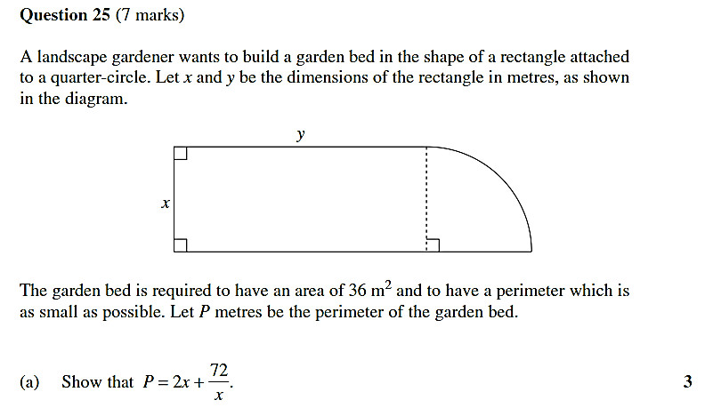

The garden bed is required to have an area of 36m2 and to have a perimeter which is as small as possible. Let  metres be the perimeter of the garden bed.

1. Show that . (3 marks)
2. Find the smallest possible perimeter of the garden bed, showing why this is the minimum. State this perimeter and the values of *x* and *y* for which it occurs.

(6 marks)

**QUESTION 7 (7 marks)**

Consider the function . The graph of its ***derivative***, , is shown below. The graph intersects the *x*-axis at the origin  and at . The point , where , is a local maximum of the graph of .

***f ’*(*x*)**

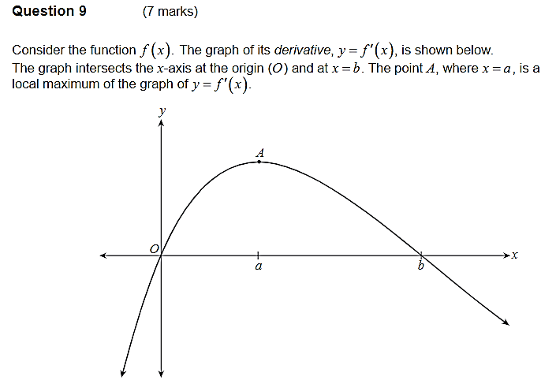

1. Complete the table below by indicating whether  and  are positive (+), negative (-) or zero (0) when  and when .

(2 marks)

|  |  |  |
| --- | --- | --- |
|  |  |  |
|  |  |  |
|  |  |  |

1. What is the nature of Point A? Justify your answer. (2 marks)
2. On the axes below, sketch a possible graph of  that passes through the origin. Clearly show the shape of the graph in the vicinities of the origin,  and .

(3 marks)

***f*(*x*)**

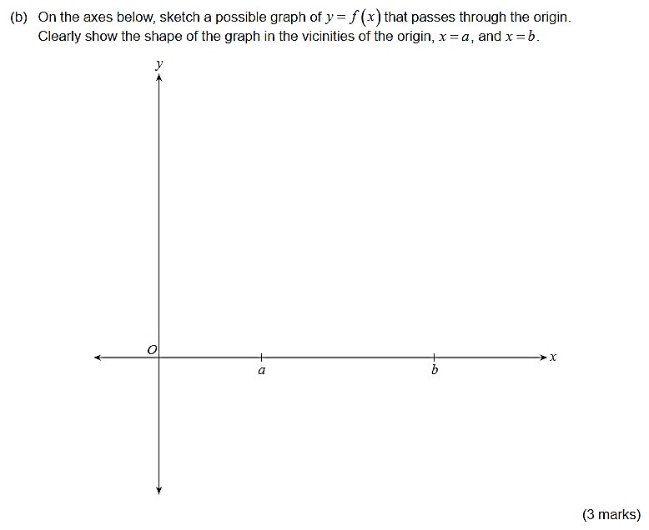

**QUESTION 8 (5 marks)**

The kinetic energy  of a body of mass  moving with velocity  is given by . If the body’s velocity is increased by 1.5%, what is the approximate percentage change in the kinetic energy?